Steps to run the program
1.Unzip the folder and open the program named as main1.m in MATLAB2022a and then click run
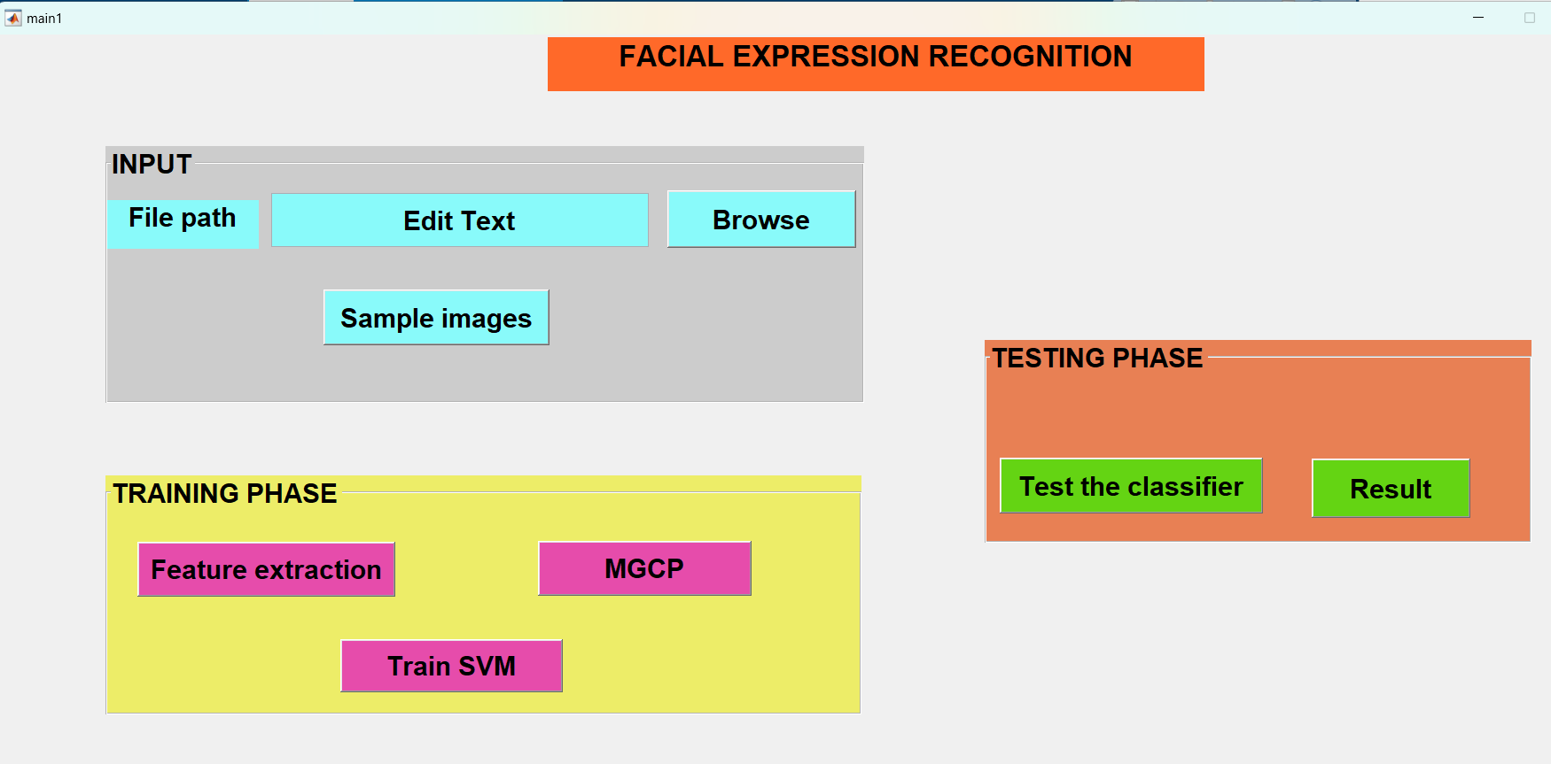
2.Click the browse button and select folder named as ck+data
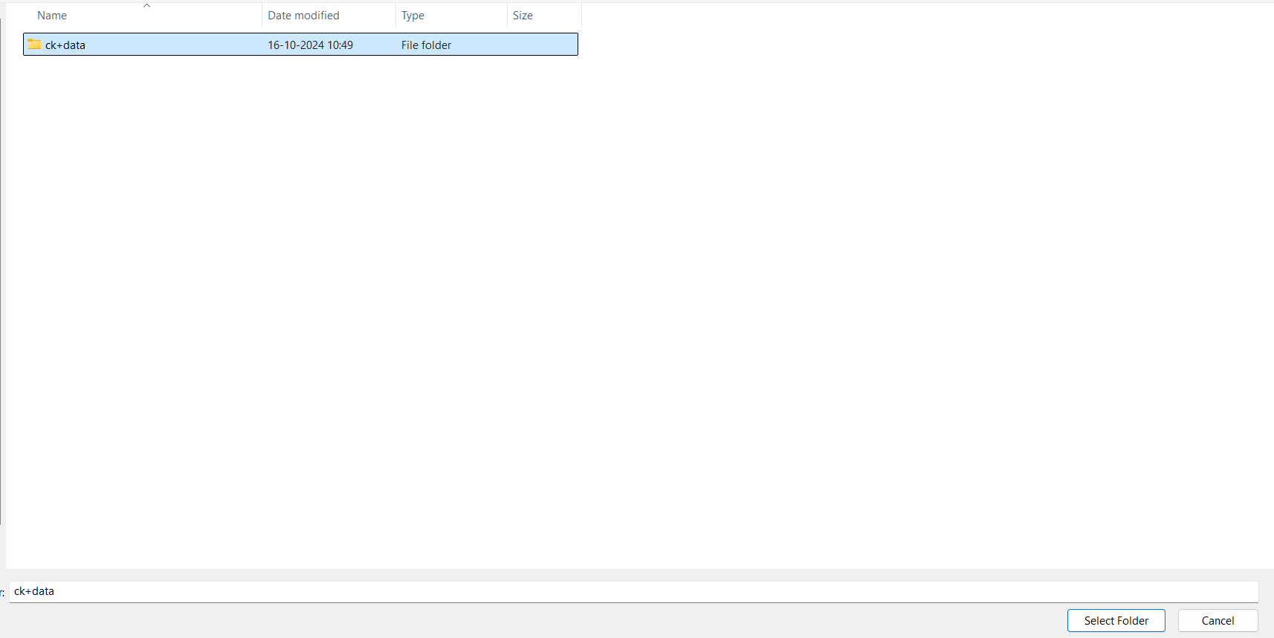
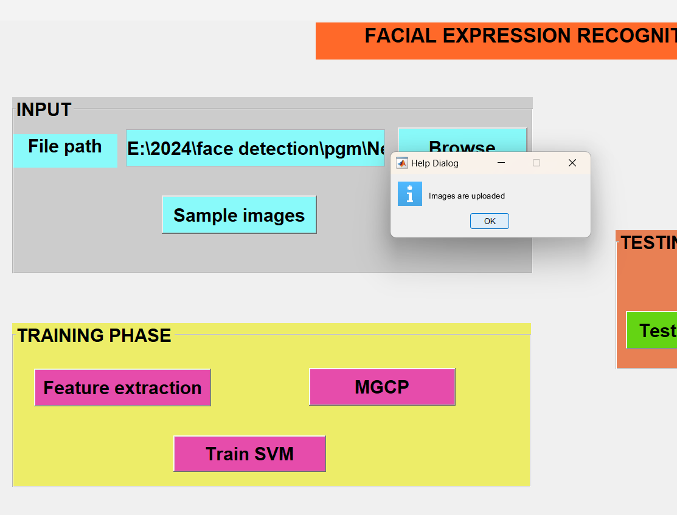
3.Click the sample images button
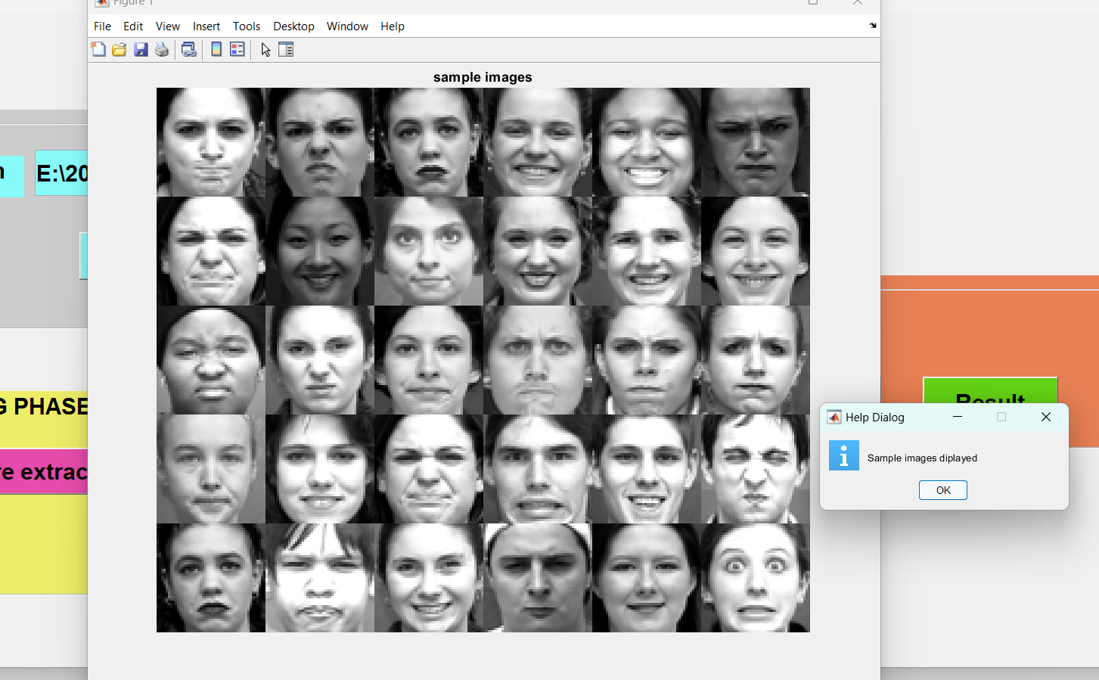
4.Hit the feature extraction button

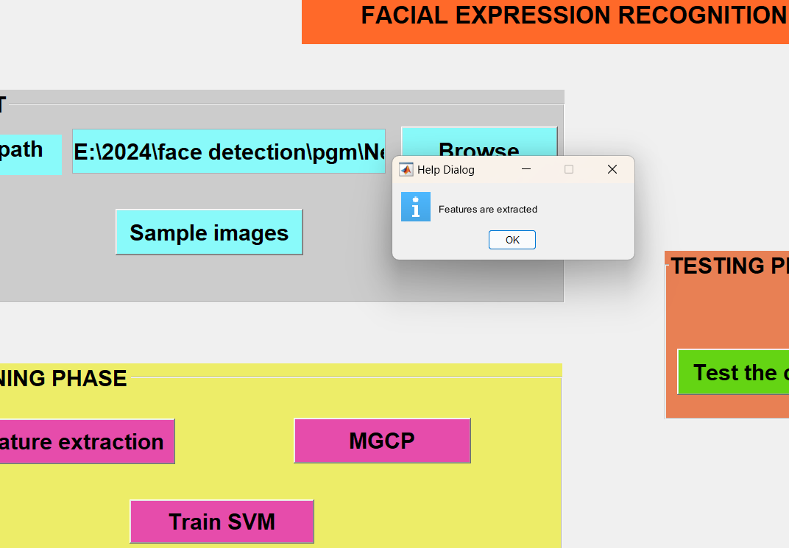
5.Click the MCGP button
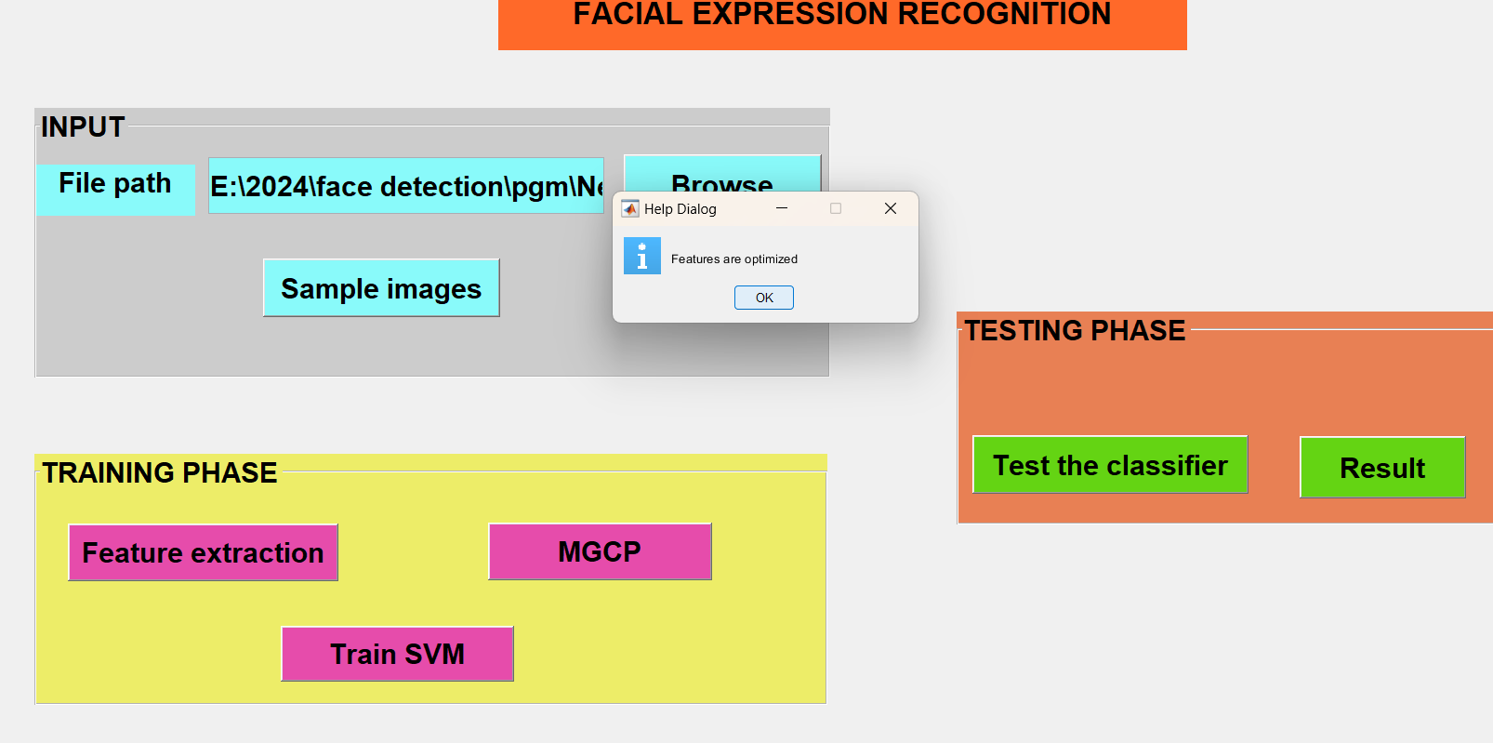
6.Hit the train SVM
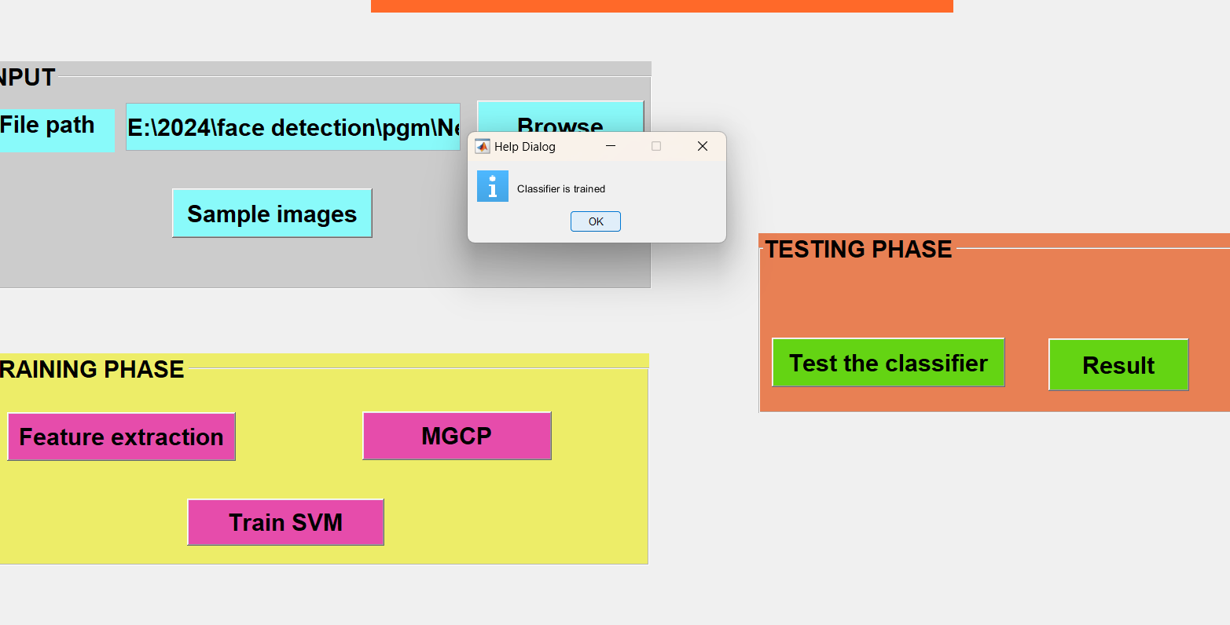

7.Click test the classifier button
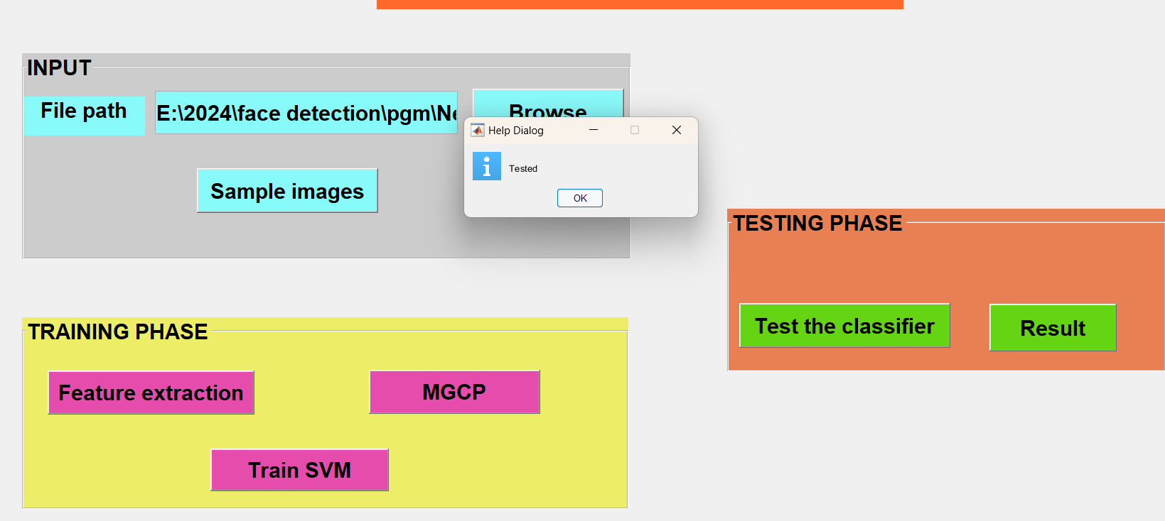
8.Hit result button
*************** Result *****************
Accuracy: 97.9592%
Precision for each class:
1.0000
1.0000
1.0000
0.8667
1.0000
1.0000
0.9600

Recall for each class:
1.0000
0.8462
1.0000
1.0000
1.0000
1.0000
0.9600